Create The IBM Watson IoT Platform and A Device

### Project title: Smart Farmer - IoT Enabled Smart Farming Application

### Team ID:PNT2022TMID32046

### Step 1

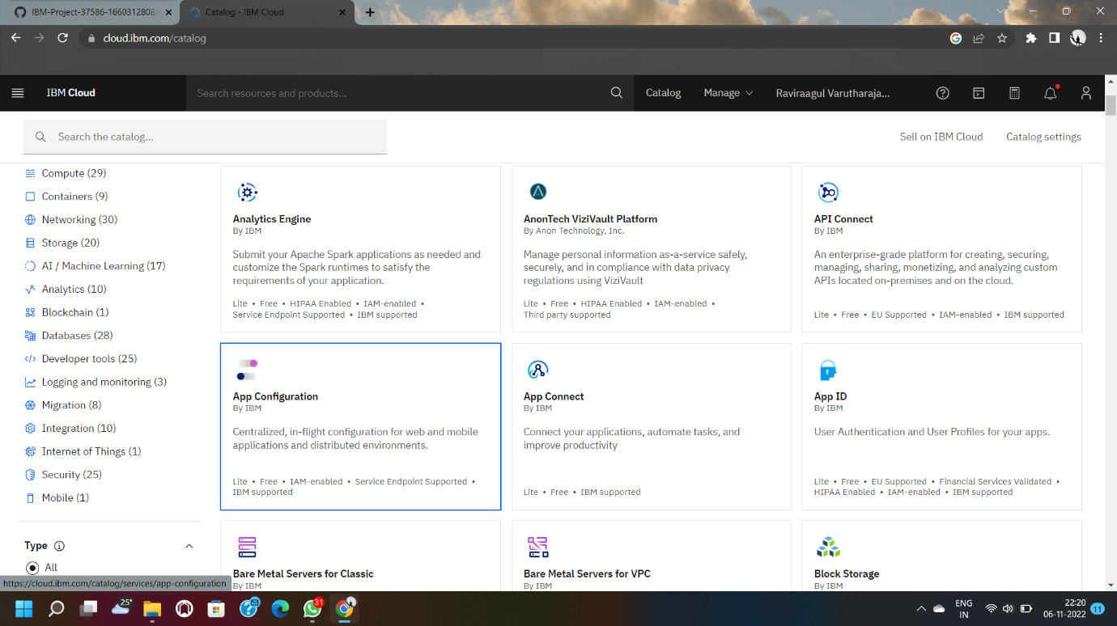

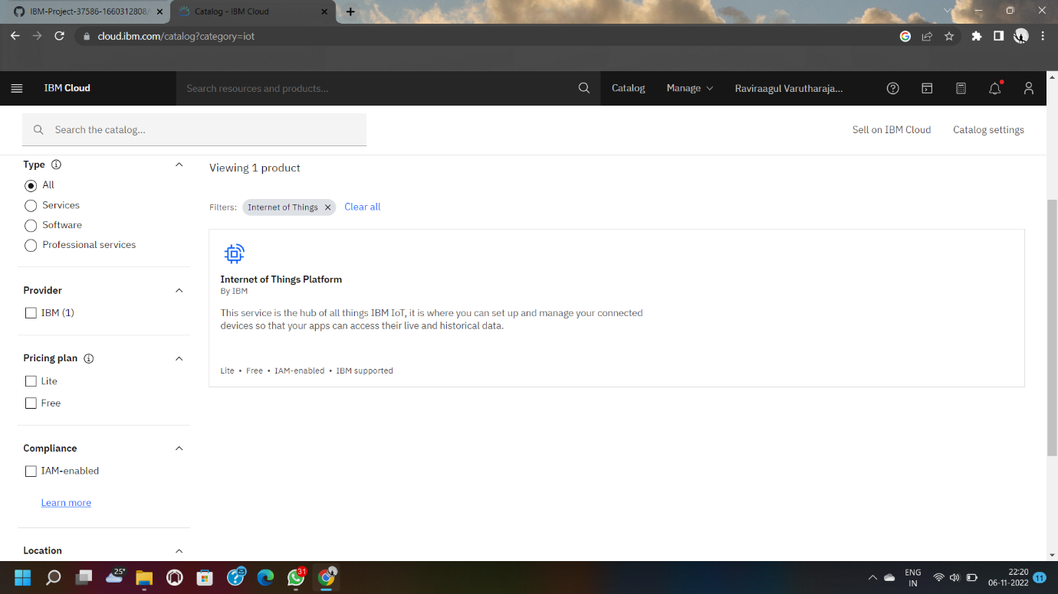

**Step 2**

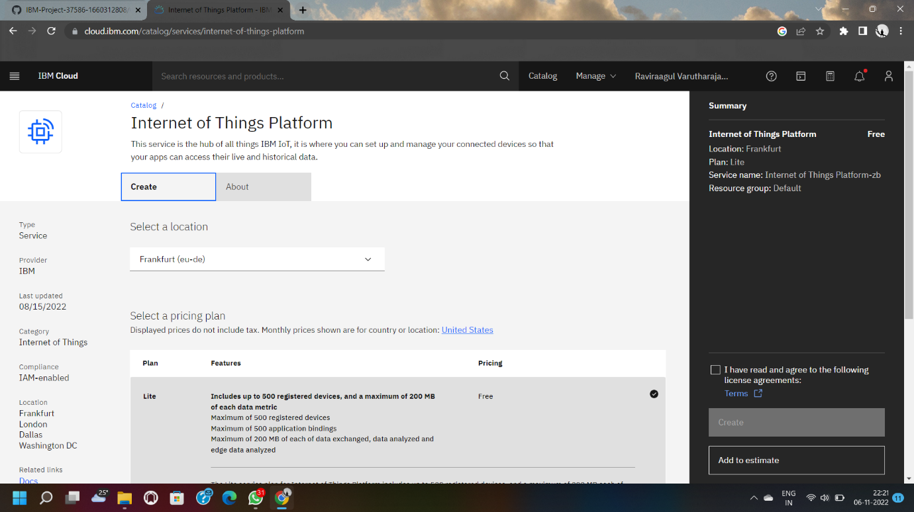

**Step 3**

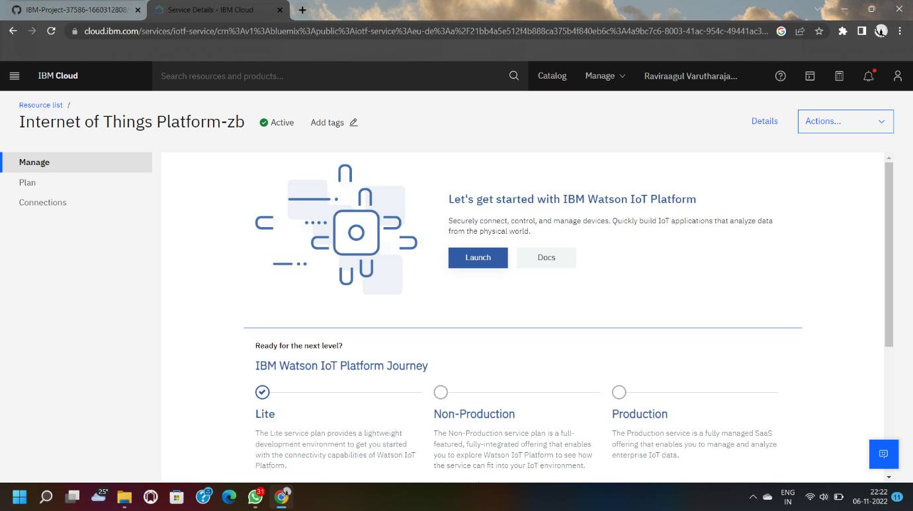

**Step 4**

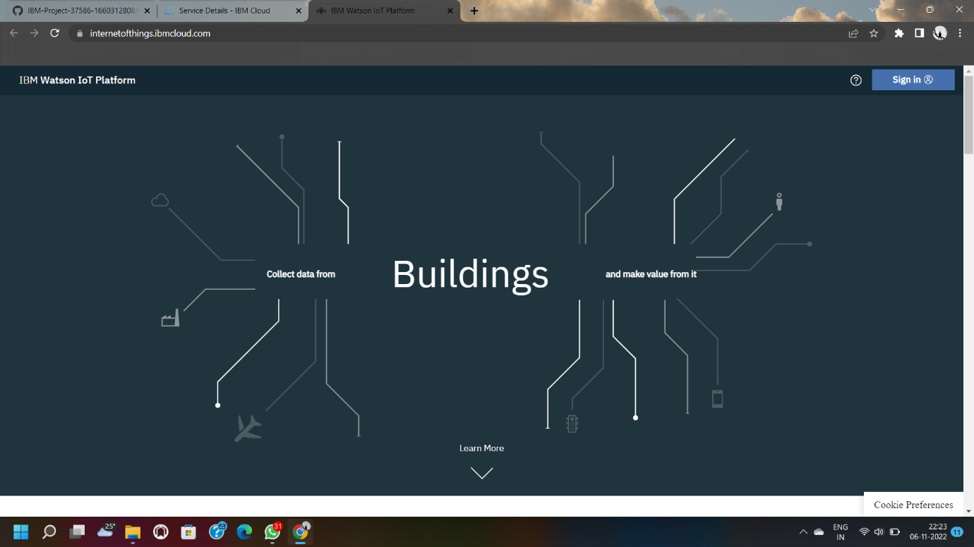

**Step 5**

